Guide to Complete Grant Proposal Form

A Grant Proposal Form is required to begin the process of finding funds for your program or project. This will serve as a guide to assist you in completing each element of the form.

- Program/Organization Name: List either your department’s name or the organization name that you are using to run the program or project (such as WU Endeavors)
- Project/Program Title: Name of the program or project that you will initiate

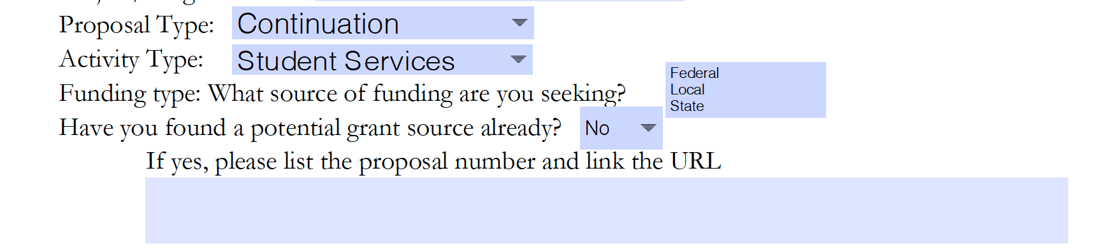
- Proposal Type: There are a variety of grant proposal types. Select the one that represents what you are looking for.

Type | Description
Continuation | Please only select this if the OSP office asks you to. This is for non-competing applications submitted System-to-System
Cooperative Agreement | Similar to a grant, but the funder will be substantially involved in the program or project proposed.
Gift | Funds or in kind donations that are given without anything needed in return
New | A new grant proposal that has not been submitted for funding prior.
Pre-Proposal | Select this option if you are required to submit a Letter of Inquiry (LOI) prior to submitting a full grant form
Renewal | Select this if you have already obtained a grant and are seeking to have that project/program refunded.
Resubmission | Select this if you are re-submitting a proposal that was not funded in the past.

- Activity Type: Select the type of activity you are proposing to do.

Type | Description
Research | Original research aimed at analyzing data to present findings.
Public Service | Program/Project that is focused on the general public (outside of the scope of the university). This will meet the needs of the community.
Education/Instruction | Anything related to educational initiatives: curriculum design, training, development, instruction.
Fellowship | Bringing students on to assist with research initiatives.
Student Services | Requesting funds for students to participate in certain programs or be awarded certain opportunities.

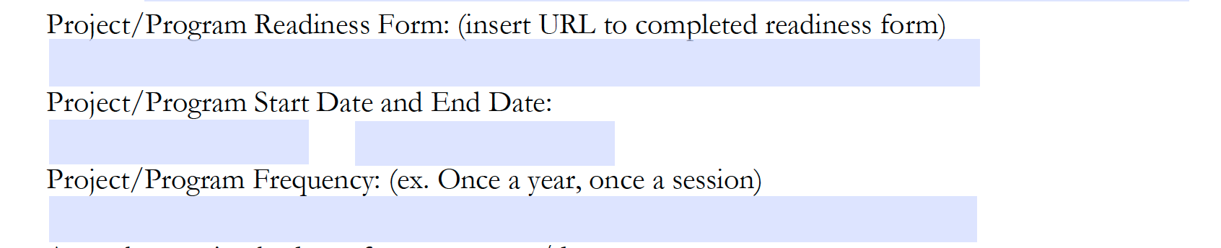
- Project/Program Readiness Form: Complete your project design information to ensure you are ready to start looking for funding. All aspects must be completed. See form here: Click here. Save as a Google Doc and upload the link in this section.

- Project/Program Start and End Date: Indicate the duration of your project or program. Ensure this is not a guess, but is a calculated consideration.

- Project/Program Frequency: If a project, there will be a definitive end date and it will run once. You can indicate ‘once’. If a program, it will either be continuous or operate at certain frequencies. You can indicate, ‘once a year,’ ‘once a month,’ or other.

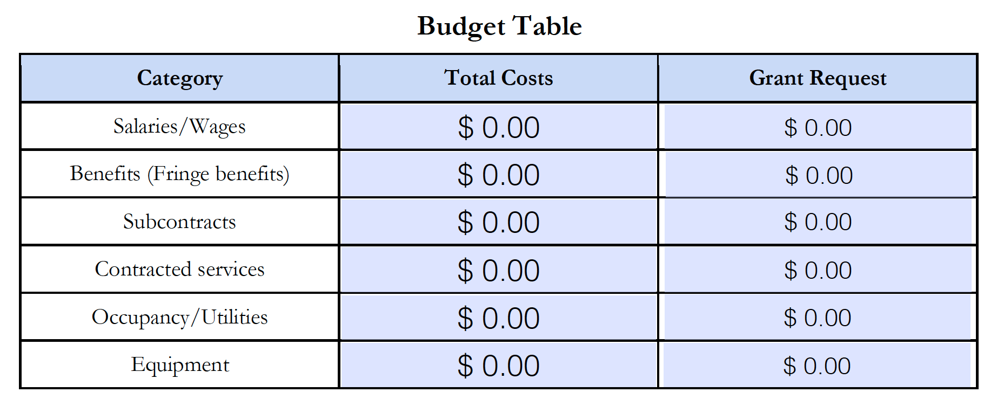
- Budget: Think through your budget for this project/program. Again, please do not guess. If you know you need equipment or resources, look at how much that will cost you before you add a number. In the project readiness form, you will include a brief narrative to explain these numbers. Here, just indicate the total costs.
Total Costs: Think about how much you need in total (even if you have already acquired additional funding).
Grant Request: How much do you need from a grant to initiate this project/program. Remember that many funders want to see that you have thought through diversified funding streams.
Sections of the Budget:
- Salaries/Wages: Ensure you know how many staff/faculty you need to run this initiative. Think through who is full time/part time/and their wages.
- Benefits: We include a percentage for benefits of full-time or eligible staff. Please see the WU information sheet for information on how to calculate this.
- Subcontracts: This will include information if you are partnering with other organizations in this initiative. How much would you need to provide to them from this grant to run the aspects they are responsible for?
- Contracted Services: This will include services that you need to provide but do not have the personnel with the expertise at the University/nonprofit. Think about things like consultants, etc.
- Occupancy/Utilities: If you are using a building, electricity, water, and more to run this program, you may list the amount it would cost here.
- Equipment: Do you need any equipment to facilitate your initiative? (For federal funding, many times, this would be items over $5,000)
- Supplies/Materials: Do you need any supplies or materials such as paper, scissors, computers, etc.
- Printing/Copying: Do you need to print or copy anything for this initiative? Is this something the university will cover or do you need funding for it?
- Communications: Do you need any funding to facilitate communications through phones, internet platforms, or the like?
- Travel: Is travel required? If so, please see the state’s website for calculating travel costs here.
- Rent: Do you need to rent a space to host this initiative? If so, please indicate that here.
- Repair/Maintenance: Do you need any of the funding to repair anything prior to its use?
- Marketing/Advertising: Do you need to pay a service to market or advertise? Do you need to pull in the marketing team from WU? Do you need this cost funded?
- Staff/Volunteer Training: Do you need to train anyone prior to the start of this initiative? Who and how long will it take? Indicate the costs associated with that.
- Miscellaneous: Anything else you can think of will go here and will be explained in the narrative.
- General Operating (indirect costs): Are there any additional indirect costs related to running this initiative? (power, administrative costs, etc.)
- In-kind: Have you received any in-kind donations from additional sources? (In-kind refers to anything that is not monetary, so think of services and goods).
- Total: Total up all costs

- How many full-time employees work in your organization? Part-time? Please find this information from your dean or chair. How many full-time employees do you have and how many part-time in your specific program?
- Has your program/organization received a grant award in the past? Indicate yes or no and if so, indicate the date. Your dean should know this information.

- What services does your organization provide? Think through your mission and list what services you provide to the institution or the community.
- Does your organization/program serve a particular location? Think through the scope of your impact. Please do not simply say worldwide.

Approvals
After you complete the information, you will need the signature of either a board member (if nonprofit) or your dean/chair. They must affirm that they are ready and capable of handling the management of the grant, want to support this initiative with outside funding, and have the faculty to be provided the hours to do this project. After you receive those signatures, you can send this to the OSP office.

