Prior to submitting to the IRB, identify which application you should consider:

Step one:
Do you qualify for minimal or no risk to participants/no participant interaction (exempt), minimal risk to participants where you are involving them in your research (expedited), or risk to participants or are incorporating sensitive information, working with vulnerable populations, etc (full).

Please check in the IRB handbook to verify which type of application to submit or after having a clear idea of your research plan, email irb@westcliff.edu for confirmation

Application Links:
1 - Exempt
2 - Expedited
3 - IRB Handbook
4 - Full Review - email irb@westcliff.edu for an application

For an outline of what to consider when completing the applications, please see below. The application structure used for this outline is the expedited application.

Important Note: You will need to adapt this and some of the sections will not apply to you. These are only suggestions for getting you to think through your research and your plan.
When you submit the application, you will not use bulleted lists. You will be typing in full paragraph form

- Explain the purpose of the study (specifically, what is your focus of research, why, and what do you hope to accomplish with it).

- Summary of the study’s methodology.
**Samples - Sample 1, Sample 2
  - What type of research are you going to do:
  - What type of data do you need in order to do this research:
  - How will you collect this data? (survey, interview, archival data, etc.)
  - How will you analyze this data?
  - How will you recruit your participants?
    - Sampling size and method
    - Where will you go to recruit your participants and by what means (advertisement, direct contact, referral, institutional request)
      - If you are recruiting at an institution, include a letter to the institution requesting permission to conduct research there
    - What will your recruitment letter/advertisement say? (add it to the application)
    - What will you offer in terms of incentive/benefit for your participants?
  - Explain the overall steps of the procedure that you will use (think of this as step-by-step what you will do. Ensure you mention how you will keep the participants safe and that their privacy is maintained)
  - Are there any materials you will use throughout your research (interview schedule, observation field notes, survey - you will add this in full form to your application).
    - If you are conducting a survey, it is important that you add the consent information on the initial page of the survey. Participants should have to click ‘yes, I accept’ or ‘no, I do not accept’ in order to access the content of the survey.

- Participant Demographics
  - Anticipated sample size (how many participants would you like to have for your study? Please explain why this is your goal and who these participants will generally consist of.
  - Special ethnic groups (racial or ethnic minorities)
  - Institutionalized or other protected group (children, prisoners, those with impaired decision-making abilities, persons under court supervision) - if any of these vulnerable groups are used, describe how, why, and how you will protect them in detail.
  - Age group:
  - General state of health:
  - Other details to describe the sample group (are there any inclusion or exclusion criteria for your sample? Explain. Or any other aspects of your group you wish to explain?)

- Will deception be used in this study? (think here about: will the participants know they are participating in a study, did you give them false information to protect a certain element of the study’s results, will they be told the information that is being collected is different that what is actually collected (this is a type of deception referred to as incomplete disclosure - an example could be - I tell the participants they are involved in a research project about the effectiveness of a standardized test’s design, when really, I am studying how music, abrupt noises, or white noises in the background are either helpful or harmful to their performance).

- Will audio or videotapes be used in the study:?
  - What are the audio/video recordings used for? Why did you choose this method?
  - What platform will you use to collect them (Zoom, tape recorder, video recorder, etc.)
  - Specify that you will tell your participants about this and when. Give them an out if they do not want to be recorded.
  - Where will you save the information after you have collected it?
  - Will you save the data with the participants names or potentially a different type of code?

- Confidentiality protection (you need to make sure no one can access the data you have collected)
  - Precautions for anonymity and privacy
    - Did you promise your participants anonymity? How will you ensure they are not identifiable?
    - How will you ensure privacy? (private rooms, closed doors (consider this in other aspects as well - if you are male/female in the room, is this appropriate? If you are in the room with a child, is this appropriate?), where will you store the information? If you are taking notes, how will you ensure no one will be able to see those, that they are safe in transport, that they are locked upon getting home, etc.)
  - Precautions to protect confidentiality in handling the data
    - When you collect the data, how will you ensure anonymity - will you remove identifying information, not collect it, give each participant a random code, etc.)
    - When you have the data, how will you save it so that no other person can access it? (keep it locked. If hard copies, consider a lock box, if digital copies, avoid the use of the cloud. You can save on your desktop in a locked folder or on a USB that is a locked)
  - Describe procedures where confidentiality may be broken (if you are in an interview, and you hear of someone who is experiencing minor abuse, elder abuse, suicidal intent, what will you do?). How will you make the participant aware of this?

- Review by institutions outside of Westcliff University
  - If you are collecting data from institutions outside of Westcliff University, state which institutions and a general plan of action - how will you contact them, what approval do you need to get first, etc. (note, that other institutions may have their own IRB committees, ensure you check if the institution you are using has one)
  - Add copies of permission letters
  - IRB certifications
  - Ethical committee outside of US

- Informed consent and assent forms
  - Templates of forms can be found through CSUSM

- Manner that informed consent will be obtained
  - Explain when you will give these forms, how you will collect them, and how you will store them

- Any possible physical, psychological, social, legal, economic, or other risks to participants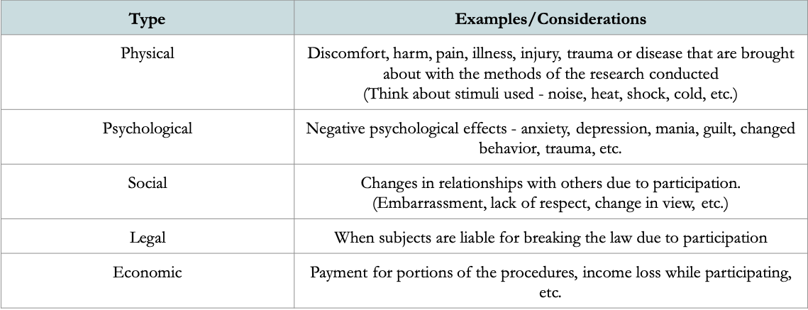

- If you have identified any of the risks, please explain how you will minimize those risks.

- Procedures to correct any harm caused.
  - If you were to find that you caused any harm to your participants, how would you take action? Would you do follow-up calls? Would you refer them to an agency that could help? (specify the potential harm and what you would do specifically)

- Indicate the potential benefit of the study
  - How could participants benefit from your study? (advocacy, involvement in progression of findings, sharing of experience, feeling heard, etc.)
  - How will your research benefit the professional community? (what is the significance of your study? Keep this narrow and focused - what is within your realm to do with this one study)

Forms we have to attach:
1 - Your CITI certifications
2 - Your professor’s CITI certification
3 - Institutional Permission Letter - this is an example of one. You will need to make your own.
4 - Assurance of Adherence to Government Regulations (outside of the US)
5 - Recruitment Letter (example of one, but you will need to make your own for your own research. This only shows you some info to include)
6 - Letters of Informed Consent - You can find samples of these online, but you will need to create your own.
7 - Data Collection Instrument (interview schedule, survey, etc.)
8 - Conflict of Interest Disclosure Statement

